13 Design PDA using simulator to accept the input string aabb

INPUT:

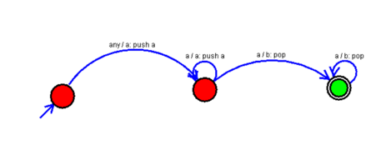

OUTPUT:

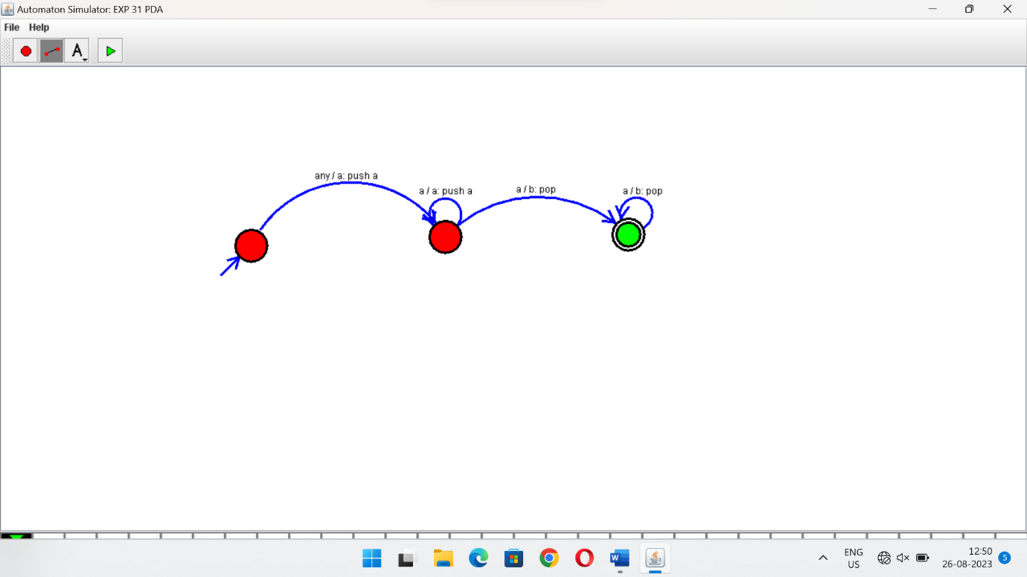

RESULTS:

PDA using simulator to accept the input string aabb